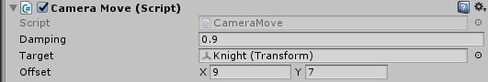  
Damping - degree of motion smoothing.  
Target - is the target followed by the camera.  
Offset – The offset of the camera from the target.  
  
  
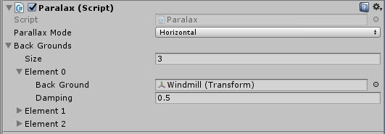  
Parallax Mode - parallax mode.   
Horizontal - only a horizontal movement.   
Vertical - only a vertical movement.  
Horizontal and Vertical - horizontal and vertical movement.  
Back Grounds - objects subject to parallax  
Back Ground – the object that will move. **Important:** the Z coordinate of object   
must not be **0**.  
Damping – degree of parallax effect.

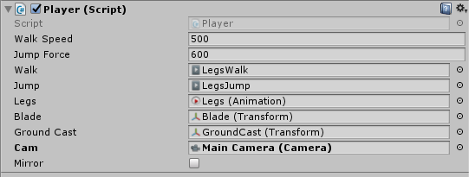  
Walk Speed - speed of the player's movement.  
Jump Force - player's jump power.  
Walk, Jump - animations of walking, jumping.  
Blade – sword of the player. Follows the mouse cursor.  
Ground Cast - A point that checks whether the player is on the ground.  
Cam - camera tracking the player.  
Mirror - A reflection of the player on the Y axis.

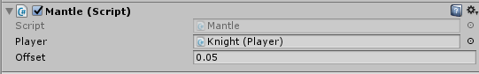  
Player – object with "Player" script"  
Offset - the degree of elongation of the mantle in motion

  
Speed – rotation speed.

